# DjangoProject

# Step1: - install virtual env using command pip install virtualenv

# Step2: - activate virtual env using command .env/Scripts/activate

# Step3: - install django using command pip install django

# Step4: - create project using command django-admin startproject {project name }

# Step5: - enter the project file env using command cd {project name}

# Step6: - start the server using command py manage.py runserver (8001 to run on specific port or usually runs on 8000 by default)

# Step7: - create a file views.py in folder where urls.py is present

# Step8: - also create templates folder in the same level as manage.py in templates we could add html files

# Step8: - also create static folder in the same level as manage.py in static folder we add css and js files

# Step9: - configure settings.py file to add css to all our html.files

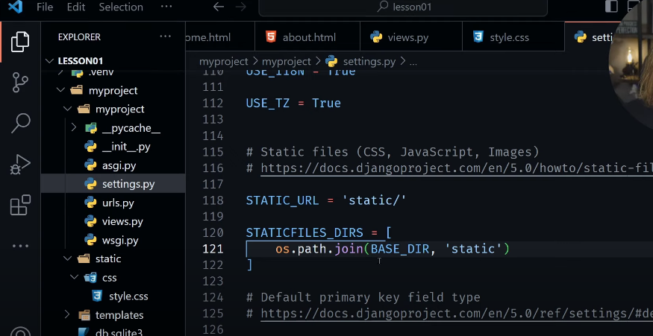

# Step10: - adding css to our html page

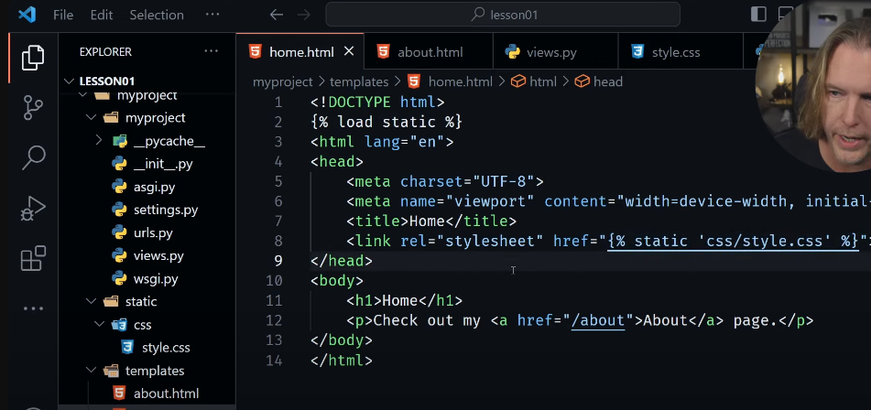

# Step11: - adding js to our html page

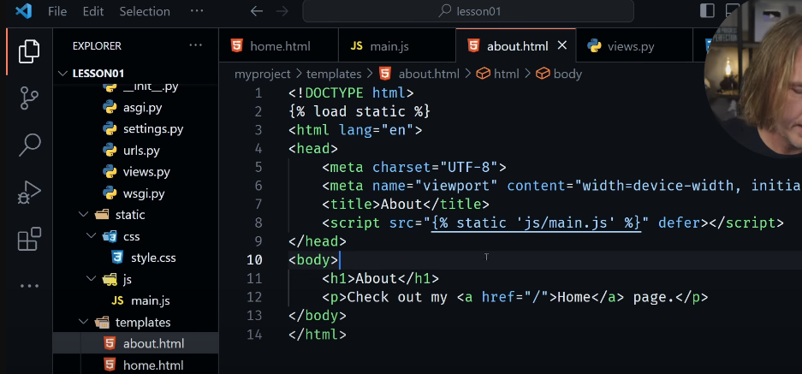

# Step12: - create app inside project using command py manage.py startapp { app name }

# Step13: - registering the app created in main project file ie. settings.py file

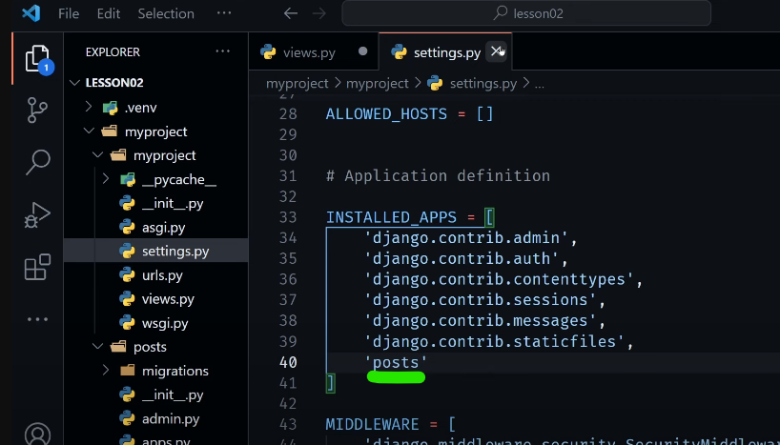

# Step14: - create a urls.py file for app we create and we need to include this file in main project urls.py file

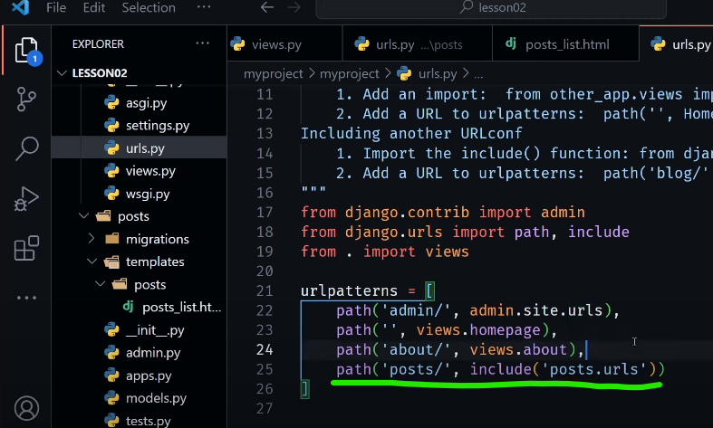

# Step15:- base template for all our html pages using {% block (name) %} ....content...... {% endblock %}

# Step16:- to use templates in other html files use {% extends 'filename.html' %}